AIM: To split the student dataset into training and testing sets in an 80:20 ratio using the train_test_split() function in Python.

ALGORITHM:
1.Start the program.
2. Import the Pandas library and train_test_split from Scikit-learn.
3. Load the student dataset from the data.csv file.
4. Remove extra spaces from the column names.
5. Select Hours studied, Attendance, and Assignment as input features.
6. Select Result as the target variable.
7. Split the dataset into 80% training data and 20% testing data using train_test_split().
8. Set random_state=42 to obtain a reproducible split.
9. Display the training data.
10. Display the testing data.
11.Display the number of training and testing samples.
12.Stop the program.

OUTPUT:
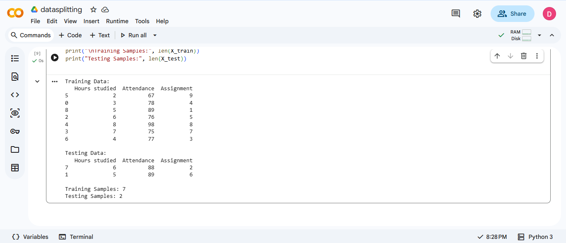

RESULT: Thus, the student dataset was successfully split into training and testing sets in an 80:20 ratio using the train_test_split() function in Python. The training and testing data were displayed along with their sample counts.

